**Faculty of Computers and Artificial intelligence**

**Cairo University**

**Simulation Project**

Submitted to:

Prof. Ayman Ghoneim

Prepared by:

|  |  |  |  |
| --- | --- | --- | --- |
| |  | | --- | | **Student name** | | **ID** | **Section** |
| Abdelrahman Mansour Mohamed | 20200295 | S1 |
| Sief Amr Mohamed | 20200242 | S2 |
| Mohamed Medhat Abdel Fattah | 20200476 | S2 |
| Abdelrahman Ehab Samir | 20200312 | S4 |

**Components**

**1.Problem Formulation ……………………………………………………………………… 3**

**2.Objectives: ……………………………………………………………………………………… 3**

**3.System Components: ……………………………………………………………………… 3**

**4.System Analysis: ……………………………………………………………………………… 3**

**5. Experimental design parameters: …………………………………………………… 7**

**6. Justification of Parameters: …………………………………………………………… 7**

**7. Result Analysis: ……………………………………………………………………………… 7**

**1.Problem Formulation:**

* Customers complaining of long waiting queues
* Meeting with Manager and customers to understand how system works

**2.Objectives:**

* Decrease waiting queues
* Increase efficiency of teller(s)
* Investigation of various scenarios

**3.System Components:**

Entity: Customers

Attribute: Account Balance

Activity: Making Deposits

Event: Arrival , Complete service

State Variable: Customer Type , Customers waiting

**4.System Analysis:**

**Calendar Table for Ordinary Customers Inter-arrival Time**

|  |  |  |  |
| --- | --- | --- | --- |
| **Inter-arrival Time** | **Probability** | **Cumulative Probability** | **Assigned Digits** |
| 0 | 0.09 | 0.09 | 01 – 09 |
| 1 | 0.17 | 0.26 | 10 – 26 |
| 2 | 0.27 | 0.53 | 27 – 53 |
| 3 | 0.20 | 0.73 | 54 – 73 |
| 4 | 0.15 | 0.88 | 74 – 88 |
| 5 | 0.12 | 1 | 89 – 00 |

|  |  |  |  |  |  |
| --- | --- | --- | --- | --- | --- |
| Customer | Assigned  Digit | Inter-arrival Time | Customer | Assigned Digit | Inter-arrival Time |
| 1 | 35 | 2 | 6 | 54 | 3 |
| 2 | 26 | 1 | 7 | 58 | 3 |
| 3 | 23 | 1 | 8 | 39 | 2 |
| 4 | 66 | 3 | 9 | 51 | 3 |
| 5 | 85 | 4 | 10 | 68 | 3 |



**Calendar Table for Ordinary Customers Service Time**

|  |  |  |  |
| --- | --- | --- | --- |
| **Service Time** | **Probability** | **Cumulative Probability** | **Assigned Digits** |
| 1 | 0.20 | 0.20 | 01 – 20 |
| 2 | 0.40 | 0.60 | 21 – 60 |
| 3 | 0.28 | 0.88 | 61 – 88 |
| 4 | 0.12 | 1 | 89 – 00 |

|  |  |  |  |  |  |
| --- | --- | --- | --- | --- | --- |
| Customer | Assigned  Digit | Service Time | Customer | Assigned Digit | Service Time |
| 1 | 63 | 3 | 6 | 36 | 2 |
| 2 | 21 | 2 | 7 | 72 | 3 |
| 3 | 73 | 3 | 8 | 46 | 2 |
| 4 | 22 | 2 | 9 | 65 | 3 |
| 5 | 67 | 3 | 10 | 13 | 1 |



**Calendar Table for Distinguished Customers Service Time**

|  |  |  |  |
| --- | --- | --- | --- |
| **Inter-arrival Time** | **Probability** | **Cumulative Probability** | **Assigned Digits** |
| 1 | 0.10 | 0.10 | 01 – 10 |
| 2 | 0.20 | 0.30 | 11 – 30 |
| 3 | 0.30 | 0.60 | 31 – 60 |
| 4 | 0.40 | 1 | 61 – 00 |

|  |  |  |  |  |  |
| --- | --- | --- | --- | --- | --- |
| Customer | Assigned  Digit | Inter-arrival Time | Customer | Assigned Digit | Inter-arrival Time |
| 1 | 36 | 3 | 6 | 2 | 1 |
| 2 | 64 | 4 | 7 | 86 | 4 |
| 3 | 8 | 1 | 8 | 89 | 4 |
| 4 | 29 | 2 | 9 | 83 | 4 |
| 5 | 13 | 2 | 10 | 70 | 4 |



**Calendar Table for Distinguished Customers Service Time**

|  |  |  |  |
| --- | --- | --- | --- |
| **Service Time** | **Probability** | **Cumulative Probability** | **Assigned Digits** |
| 1 | 0.10 | 0.10 | 01 – 10 |
| 2 | 0.30 | 0.40 | 11 – 40 |
| 3 | 0.38 | 0.78 | 41 – 78 |
| 4 | 0.22 | 1 | 79 – 00 |

|  |  |  |  |  |  |
| --- | --- | --- | --- | --- | --- |
| Customer | Assigned  Digit | Service Time | Customer | Assigned Digit | Service Time |
| 1 | 89 | 4 | 6 | 66 | 3 |
| 2 | 8 | 1 | 7 | 84 | 4 |
| 3 | 37 | 2 | 8 | 71 | 3 |
| 4 | 62 | 3 | 9 | 82 | 4 |
| 5 | 77 | 3 | 10 | 13 | 1 |



**Simulation for 10 customers of each type:**

|  |  |  |  |  |  |  |  |  |  |
| --- | --- | --- | --- | --- | --- | --- | --- | --- | --- |
| **Customer** | **Type** | **Inter-arrival** | **Arrival** | **Waiting** | **Service Start** | **Service** | **Completed** | **System** | **Teller Idle** |
| 1 | O | 2 | 2 | 0 | 2 | 3 | 5 | 3 | 2 |
| 2 | D | 3 | 3 | 2 | 5 | 4 | 9 | 6 | 0 |
| 3 | D | 4 | 8 | 5 | 9 | 1 | 10 | 6 | 0 |
| 4 | O | 1 | 3 | 9 | 10 | 2 | 12 | 11 | 0 |
| 5 | D | 1 | 9 | 3 | 12 | 2 | 14 | 5 | 0 |
| 6 | D | 2 | 11 | 3 | 14 | 3 | 17 | 6 | 0 |
| 7 | D | 2 | 13 | 4 | 17 | 3 | 20 | 7 | 0 |
| 8 | D | 1 | 14 | 6 | 20 | 3 | 23 | 9 | 0 |
| 9 | D | 4 | 18 | 5 | 23 | 4 | 27 | 9 | 0 |
| 10 | D | 4 | 22 | 4 | 27 | 3 | 30 | 7 | 0 |
| 11 | D | 4 | 26 | 4 | 30 | 4 | 34 | 8 | 0 |
| 12 | D | 4 | 30 | 4 | 34 | 1 | 35 | 5 | 0 |
| 13 | O | 1 | 4 | 31 | 35 | 3 | 38 | 34 | 0 |
| 14 | O | 3 | 7 | 31 | 38 | 2 | 40 | 33 | 0 |
| 15 | O | 4 | 11 | 29 | 40 | 3 | 43 | 32 | 0 |
| 16 | O | 3 | 14 | 29 | 43 | 2 | 45 | 31 | 0 |
| 17 | O | 3 | 17 | 28 | 45 | 3 | 48 | 31 | 0 |
| 18 | O | 2 | 19 | 29 | 48 | 2 | 50 | 31 | 0 |
| 19 | O | 3 | 22 | 28 | 50 | 3 | 53 | 31 | 0 |
| 20 | O | 3 | 25 | 28 | 53 | 1 | 54 | 29 | 0 |
| Total |  |  |  | 282 |  | 49 |  | 334 | 2 |
| Average |  |  |  | 14.1 |  | 2.45 |  | 16.7 | 0.2 |

**5. Experimental design parameters:**

* We have two types of experimental parameters:-
* Probalistic parameters such as: Inter-arrival Time , Service Time
* Controllable parameters such as: Number of tellers , type of customers
* We are going to add a teller specially for distinguished customers
* We are going to add equal number of customer types

**6. Justification of Parameters:**

* Because waiting probability is high for both types of customers we need to add more staff to relief the stress and decrease probability
* Adding equal number of customer types to make accurate comparisons between the two types

**7. Result Analysis:**

**Histogram of Ordinary customer Service Time**

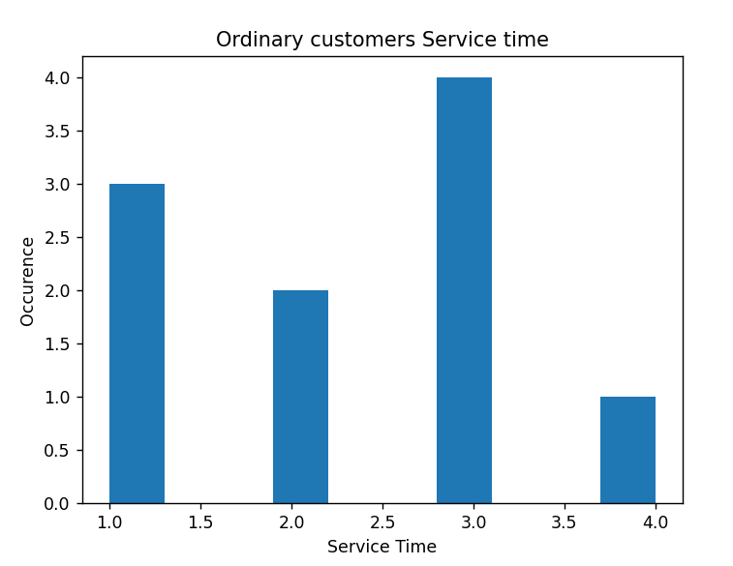

**Histogram of Distinguished customer Service Time**

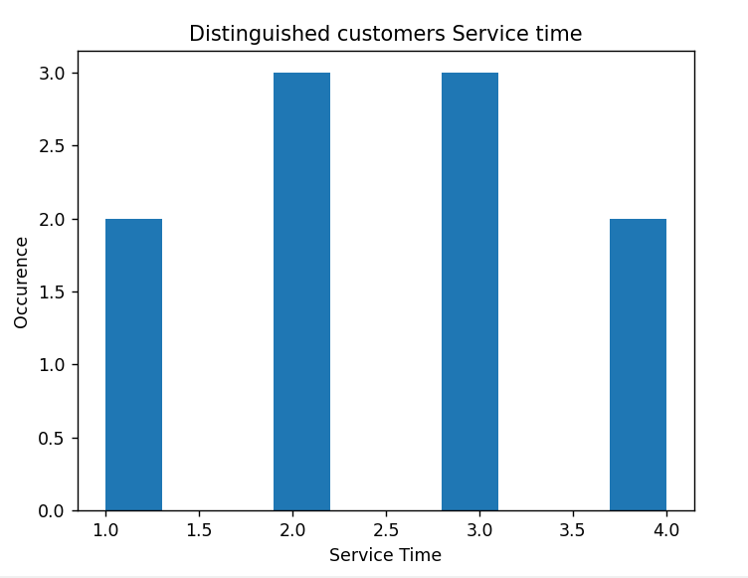

**Histogram of Ordinary customer Service Time**

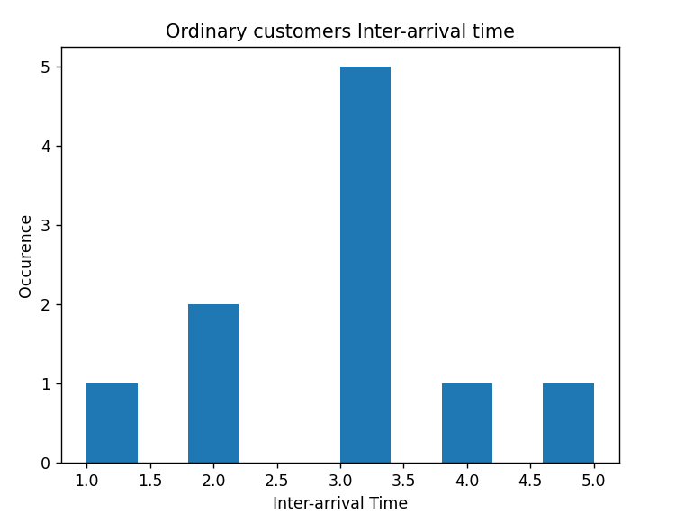

**Histogram of Distinguished customer Service Time**

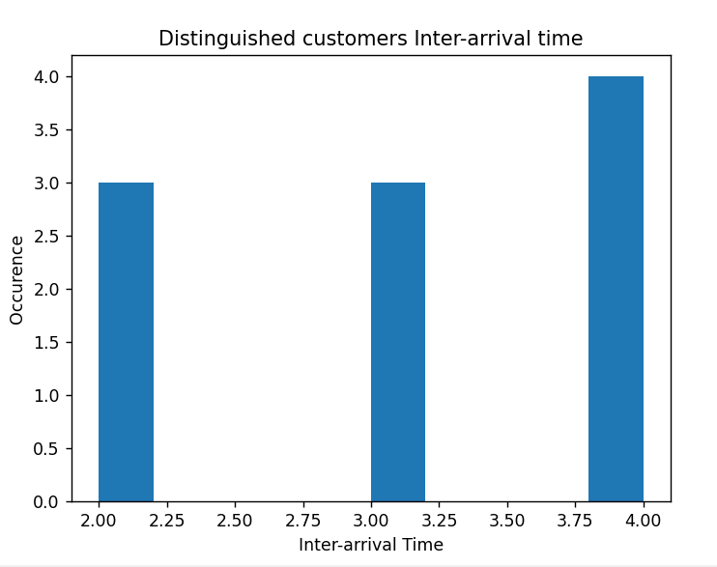

**Histogram of Ordinary customer waiting Time with 1 teller**

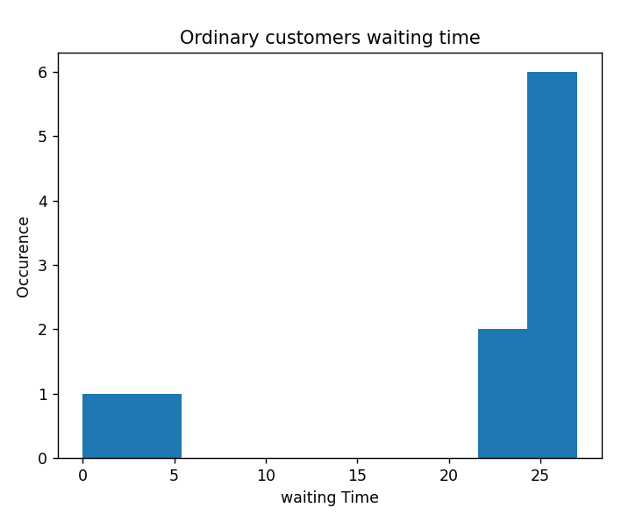

**Histogram of Distinguished Waiting Time with 1 teller**

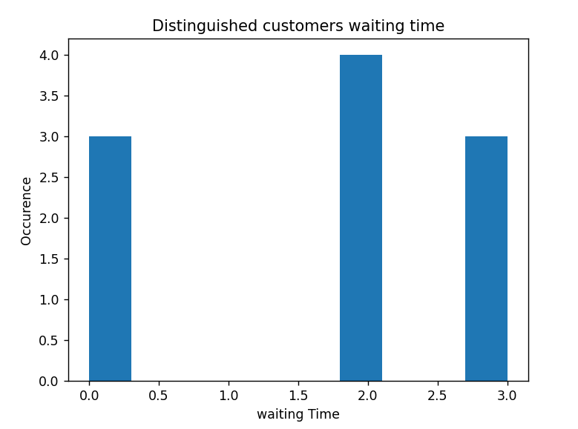

**Q.1 The average service time of the teller.**

* **2.45**

**Q.2 The average waiting time in the ordinary customers queue and the distinguished customers queue**

* 24.2 for Ordinary Queue
* 4.4 for Distinguished Queue

**Q.3 The maximum ordinary customers queue length and the distinguished customers queue length.**

* 31 for Ordinary Queue
* 6 for Distinguished Queue

**Q.4 The probability that an ordinary customer wait in the queue, and the probability that a distinguished customer wait in the queue.**

* 0.92 for Ordinary Customer
* 0.98 for Distinguished Customer

**Q.5 The portion of idle time of the teller.**

* Teller was idle for 2 min which is about 0.037 of Time on server

**Q.6 Does the theoretical average service time of the service time distribution match with the experimental one for both types of customers?**

* No They don’t match as shown in both Simulation Table and histograms

**Q.7 Does the theoretical average inter-arrival time of the inter-arrival time distribution match with the experimental one for both types of customers?**

* No They don’t match as shown in both simulation Table and histograms

**Histogram of Ordinary customer waiting Time with 2 teller**

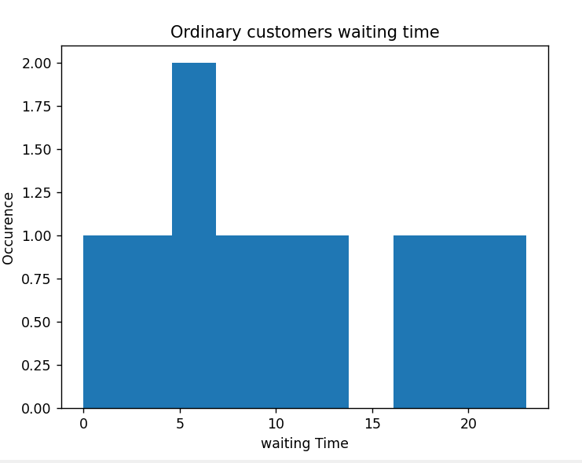

**Histogram of Distinguished Waiting Time with 2 teller**

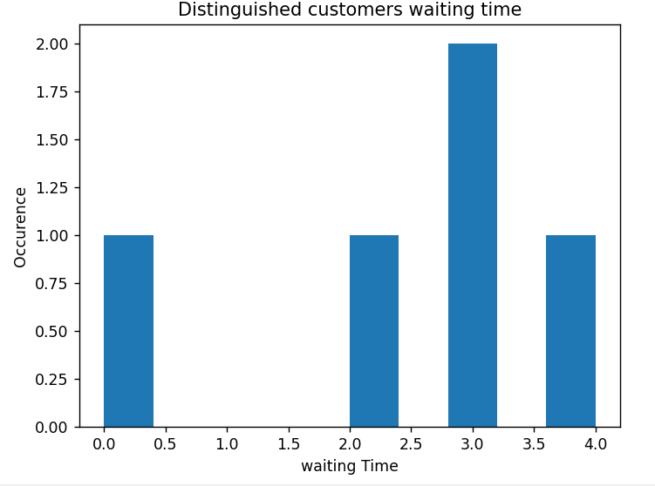

**Screenshot from run for previous 2 histograms**

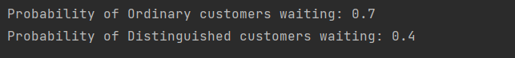

**Q.8 If there is an additional teller to serve the distinguished customers only, how does this affect the average waiting time in the queues of both types of**

**customers?**

* It decreases probability of waiting for Ordinary customers and Significantly for Distinguished Customers